Admin Notes:
- You should only be utilizing the AWS Workspaces service for the HTM course
- You will only need to manage the workspaces.
- If we haven’t covered a piece of the solution, please let me know prior to making any changes as unexpected costs could result.

Notes for the course:
- Prior to the start of each day, you should spin up the virtual desktops so the students don’t have to wait for the desktops to resume. This can be done via the AWS management console.
  - Resuming the workspaces mentioned above typically takes 5 minutes
- Logging into a resumed/running workspaces should take at max 30 seconds (see the common issues below)
- Desktops timeout after 3 hours of inactivity
  - Keep the backups active/running
- Some expected actions during course
  - Administer the spreadsheet that assigns folks to the virtual desktops
    - Update as needed if new folks join the course or if you need to switch them to a backup (if theirs isn’t working)
  - Manually reboot a desktop if frozen/black screen
- You may want to install the local AWS Workspace Client as it can help in troubleshooting if students have issues logging in.
  - Other than a black screen, it’s usually user error, not technical issues.
- There can only be one connection open to a Workspace at a time. If you want to try logging into the workspace, let the student know their session will end so they aren’t surprised.

Class Start Time: 0900 ET

0815 ET:
- Log in to AWS Management Console
- Account ID: 566937488447
- Username: <<firstname>>.<<lastname>>
- Password:
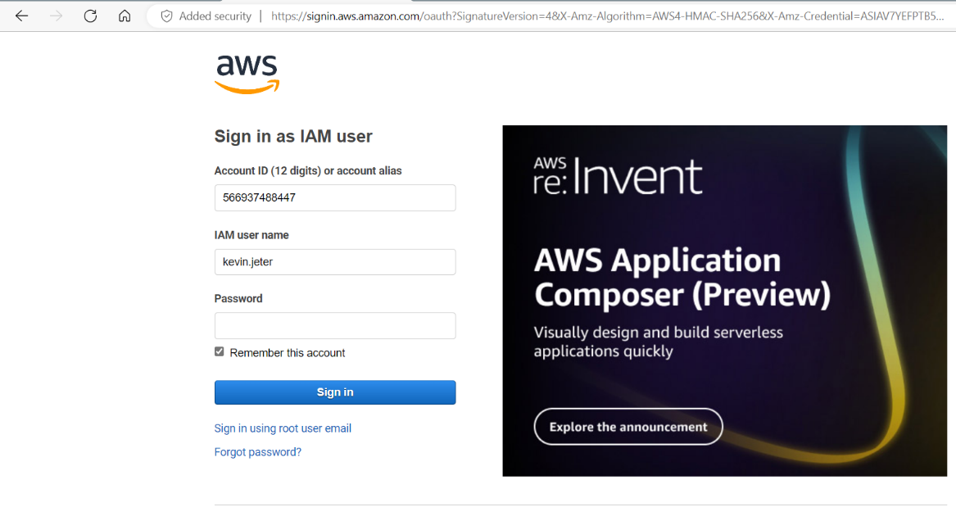
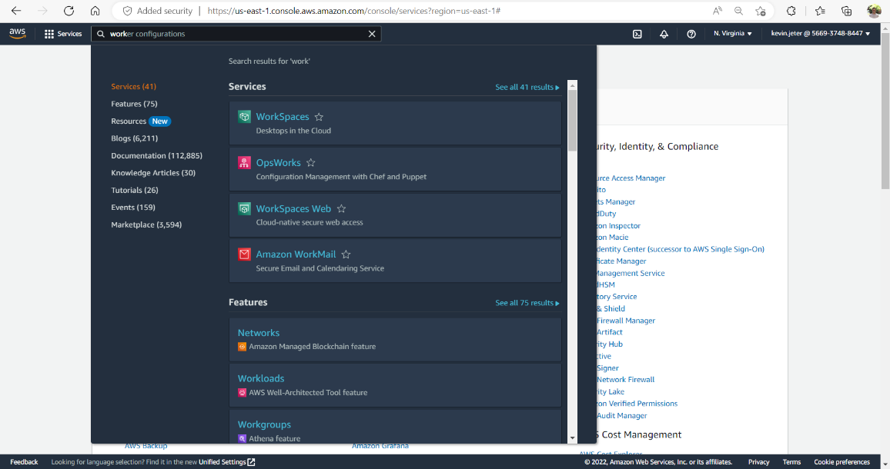
- Start all HTM Workspaces that start with “HTM”
- All workspaces that start with “L” are Linux and ONLY used for HTM211: Intro. to OS/SQL in the afternoon of Day 2
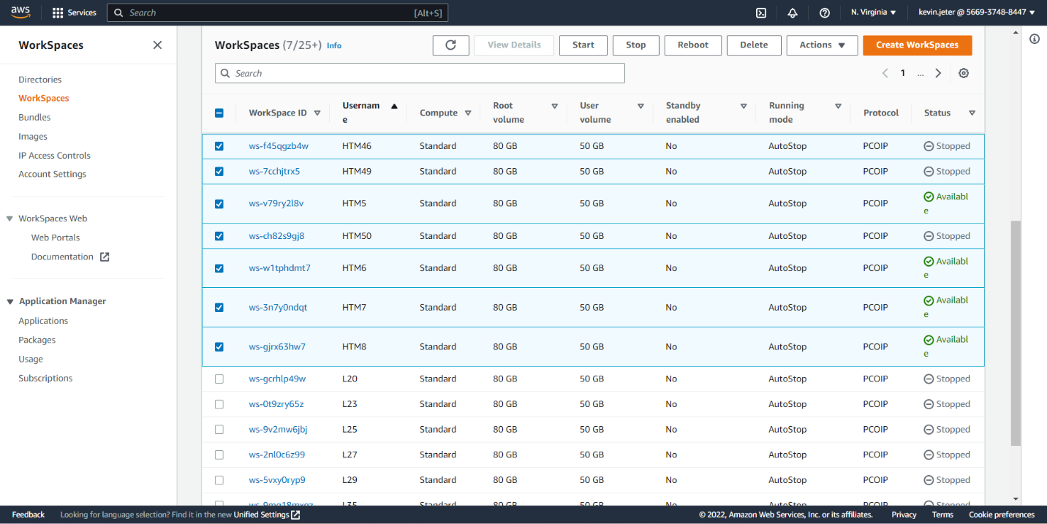
- Pull up AWS Login Information Spreadsheet on VA Computer (the version being updated w/ reassignments)
  - Log in to all extra, unassigned desktops in browser windows
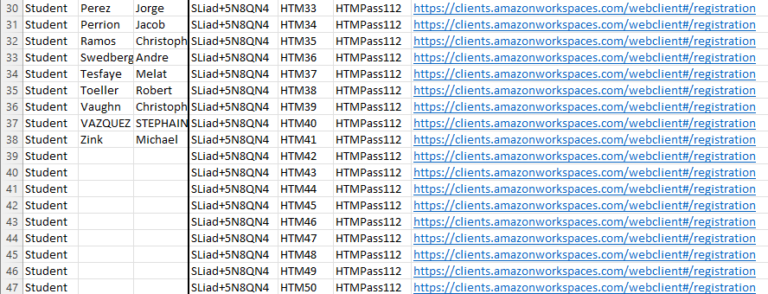

0830 ET:
- Log in to AWS Management Console
- Navigate to the Workspace Management Console and check the ‘Status’ of all ‘HTM’ desktops.
  - If any are marked as anything EXCEPT “Available,” select the workspace and Reboot
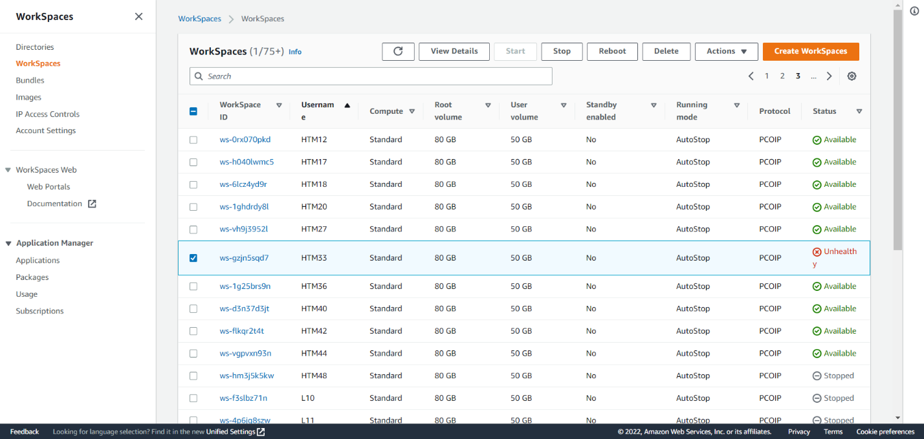
- Start/Join the MS Teams Course Meeting & greet people as they join.
  - Instruct them to log in to their Amazon Workspaces with the following instructions
Amazon WorkSpaces Web Access
Registration Code: SLiad+5N8QN4
Username: <<VA SP Link>> or ask <<Moderator Name>>
Password: <<HTMPass###>>
- Troubleshoot as necessary

Common Troubleshooting & Errors
- 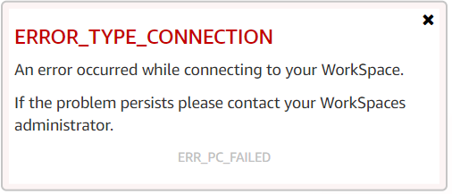
  - When logging in for the first time -- the sign-in screen just timed-out. The desktop is likely to have already resumed. The user just needs to go through the login again.
  - If the error keeps occurring – someone else may be logging into the assigned persons username. Ensure the username is correct & that no one else is using it. If necessary, assign a new username & retire the desktop
  - After reassignment & error continues – this is an internet connectivity issue on their side. If at VA Facility, ensure they are NOT on the guest network & recommend obtaining a secondary device. If at home network, ensure they are NOT on VPN & recommend closing all tabs/other windows.
- 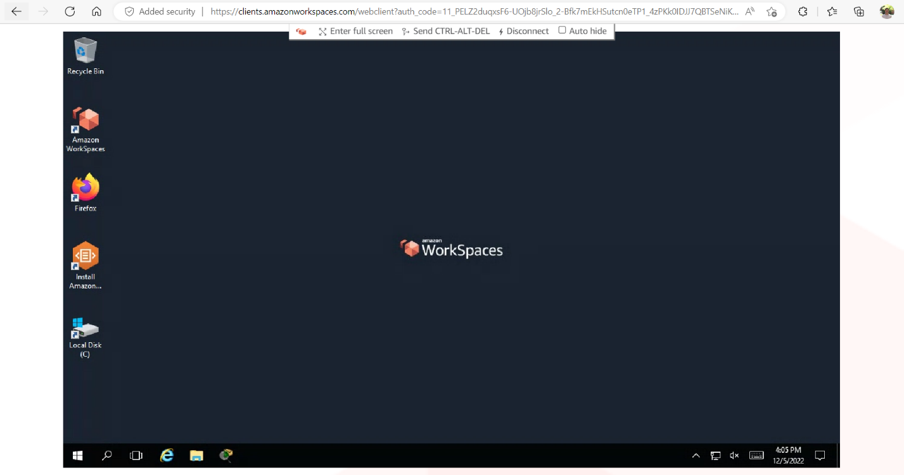
  - Immediately reassign them a new username
    - In management console, select the workspace & reboot, then log into desktop to ensure it is working.
- Most errors are user errors.
  - Recommended to log into the problematic workspace in your web browser. When the “ERROR_TYPE_CONNECTION” pops up & you lose access to the desktop, the student has successfully logged in
  - Recommended to have student share their screen, if possible, in order to effectively troubleshoot
  - Some users attempt to log into their workspace via the Amazon Workspace App on the virtual desktop. If their workspace looks like the one below – ensure they close the internal Amazon Workspace Window within their Amazon Workspace
